**File permissions in Linux**

**Project description**

In this project, I examined and updated Linux file and directory permissions for the research team. I ensured that only authorized users could read or modify files, and that sensitive directories were restricted to the owner. This was done by checking current permissions, interpreting permission strings, and modifying them using chmod commands.

* **Check file and directory details**
* Command used:

*ls -la /home/researcher2/projects*

* Explanation:
* ls lists directory contents
* -l shows details (permissions, owner, group, size, date)
* -a includes hidden files (names starting with .)
* Output:

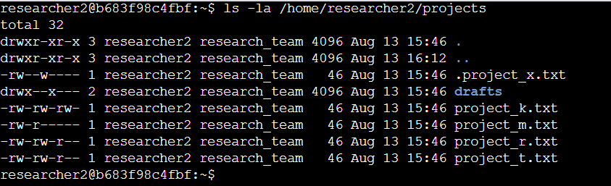

* **Describe the permissions string**

***Example string:  
-rw-rw-rw-***

Meaning:  
- '-' : regular file  
- 'rw-' : owner can read and write  
- 'rw-' : group can read and write  
- 'rw-' : others can read and write  
  
This allows all users to modify the file, which violates the organization’s policy.

* **Change file permissions**

File: project_k.txt

* Before change:

*ls -l /home/researcher2/projects/project_k.txt*

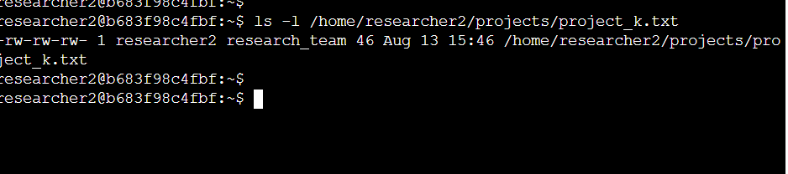

* Command used:

*chmod o-w /home/researcher2/projects/project_k.txt*

* After change:

*ls -l /home/researcher2/projects/project_k.txt*

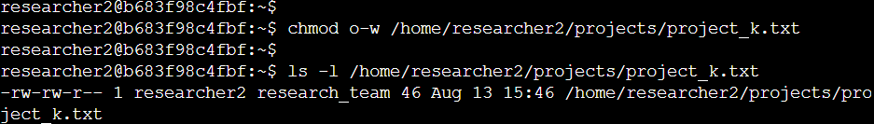

* Explanation:  
  Removed write permission from “others” to comply with policy.
* **Change file permissions on a hidden file**

File: .project_x.txt

* Before change:

*ls -l /home/researcher2/projects/.project_x.txt*

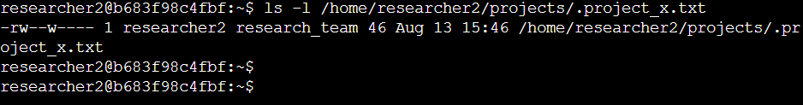

* Command used:

*chmod 440 /home/researcher2/projects/.project_x.txt*

* After change:

*ls -l /home/researcher2/projects/.project_x.txt*

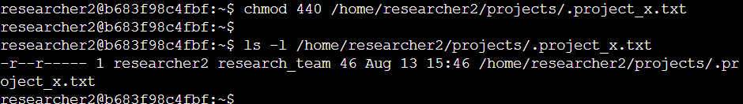

* Explanation:  
  Set read-only permission for owner and group, no access for others.
* **Change directory permissions**

Directory: drafts

* Before change:

*ls -ld /home/researcher2/projects/drafts*

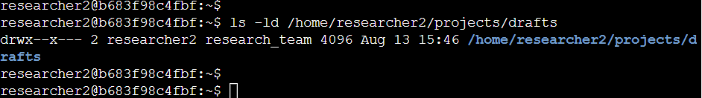

* Command used:

*chmod g-x /home/researcher2/projects/drafts*

* After change:

*ls -ld /home/researcher2/projects/drafts*

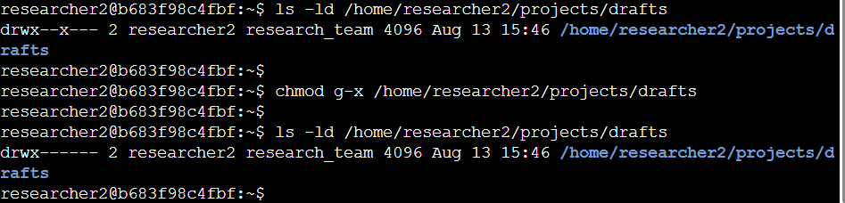

* Explanation:  
  Removed execute permission for the group so only the owner can access.

**Summary**

I inspected the permissions of files and directories in /home/researcher2/projects using ls -la, identified unauthorized write and execute permissions, and corrected them with chmod. I removed write access for others on project_k.txt, secured the hidden file .project_x.txt to read-only for user and group, and restricted the drafts directory so only the owner could access it. These changes strengthen security and prevent unauthorized access or modification of research files.